Adrian Rendon, MD, PhD

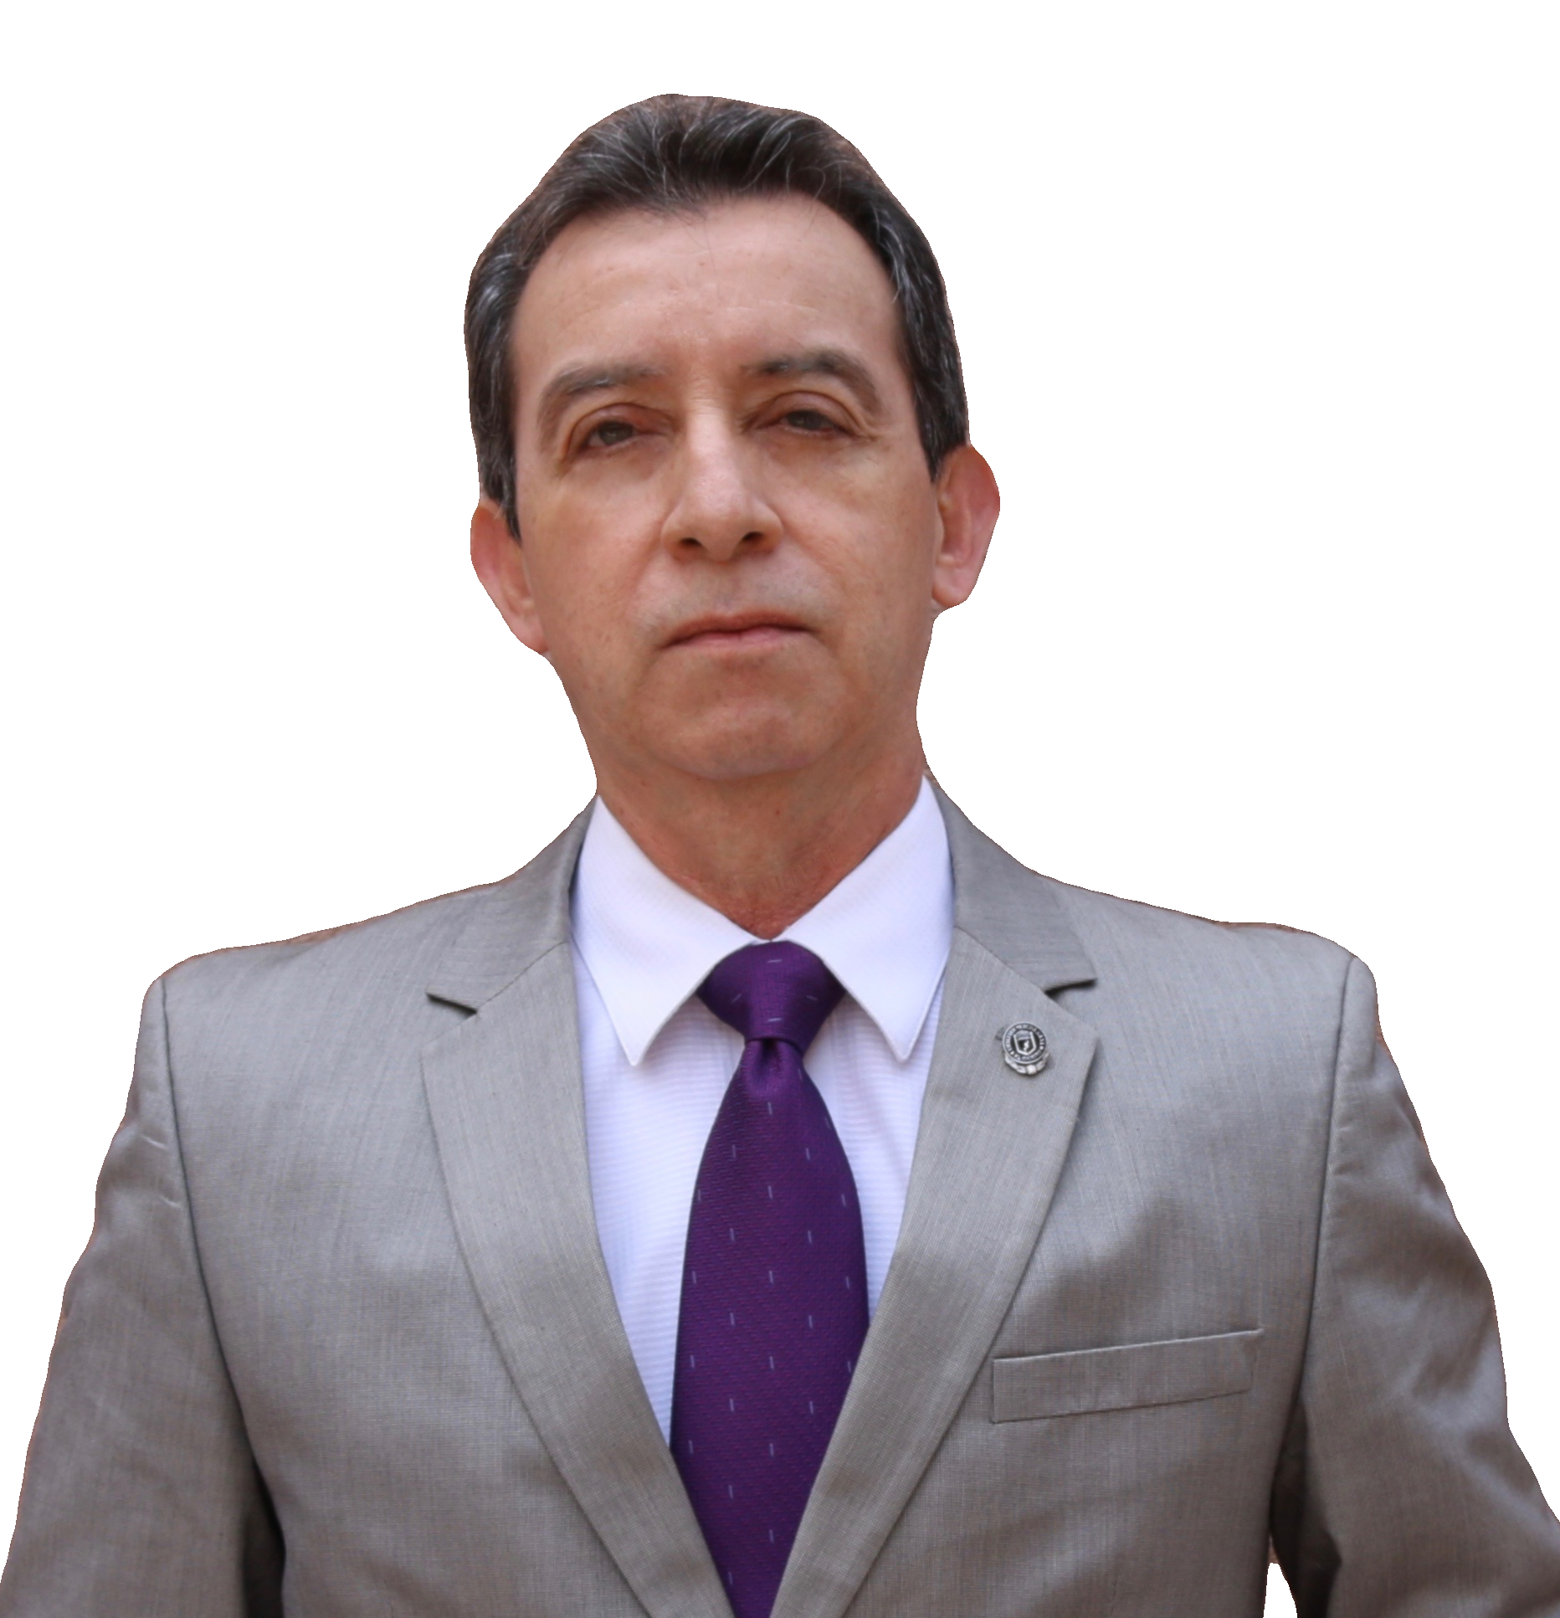
- Internal Medicine and Pulmonary and Critical Care Medicine specialist
- Postgraduate training at University of Arkansas for Med Sciences, National Jewish Med Ctr and Baylor University Med Ctr
- Firt place Class 1985, School of Medicine
- Chief Resident, Internal Medicine program
- Chief Fellow, Pulmonary and Critical Care Medicine program
- PhD, Summa cum laude
- Mexican Research System Level III (highest)
- National Academy of Medicine member

RESEARCH PRODUCTION
- 74 manuscripts in PubMed with > 1,900 citations, Index H-25
- Reviewer and editor of several international medical journals

SPEAKER ON SEVERAL INTERNATIONAL MEETINGS INCLUDING:

ATS conference, CHEST congress, ERS congress, ALAT congress, The UNION congress, SEPAR congress

POSSITIONS
      - Professor of Medicine at the School of Medicine and University Hospital of Monterrey UANL since 1993: Internal Medicine and Pulmonary and Critical Care Program
      - Chief, Center for Research and Prevention of Respiratory Infections, University Hospital of Monterrey
      - Member of the WHO/PAHO Green Light Committee
      - Member of the Work Group on Vaccination and immunization, American Thoracic Society (ATS)
      - Member of the Scientific Committee of the Asociación Latino Americana de Tórax (ALAT)
      - Past President Mexican Pulmonary Society (SMNyCT) 2019-2021
      - Chief, Infections and Tuberculosis section of the SMNyCT 2021-2023
      - Advisor of the Nuevo León state Health Department during the COVID-19 campaign
      - Member of the National Advisory Drug Resistant TB Committee

